

How to be included in

Orleton Village Magazine

This magazine will be published on the first day of each month on the Village Website: *www.orletonvillage.co.uk.* Notification of publication, together with a link, will be given on Nextdoor and Orleton Village Chat (Facebook)

Articles of general interest, club or association reports and advertisements for community events may be included without charge. Commercial advertisements are charged, dependent on size. (Rates available on request from: [orletonmagazine@gmail.com](mailto:orletonmagazine@gmail.com))

Small private sale advertisements may be accepted without charge if space allows

**Orleton Village Hall**

**Ideal venue for family events, parties, weddings, concerts, dances,**

**training courses, drama performance, exhibitions, classes and craft fairs.**

**Large hall (160 seating capacity) with proscenium stage, theatre lighting and sound system, electric piano, video projector and radio mike.**

**Additional small hall (50 capacity)**

**Superb five star rated kitchen, cutlery and crockery. Large car park.Free Wi-Fi**

**Also tables, chairs and marquee available for hire for garden parties**

**For bookings /quotations: bookings@orletonvillage.co.uk**

**Tel 01568 780583**

All content is accepted at the discretion of the editorial team. Articles that are disrespectful or prejudicial will not be accepted.

Copy should be submitted as Word or PDF files. If hard copy is submitted there may be a charge for scanning and input.

All copy must be accompanied by the name, address and telephone number of the author, although this will not be included unless incorporated into the article.

Articles for publication should be emailed to: orletonmagazine@gmail.com by the 20th of the month prior to desired publication

**Editorial**

**Orleton Village Hall**

**Ideal venue for family events, parties, weddings, concerts, dances,**

**training courses, drama performance, exhibitions, classes and craft fairs.**

**Large hall (160 seating capacity) with proscenium stage, theatre lighting and sound system, electric piano, video projector and radio mike.**

**Additional small hall (50 capacity)**

**Superb five star rated kitchen, cutlery and crockery. Large car park. Free Wi-Fi**

**Also tables, chairs and marquee available for hire for garden parties**

**For bookings /quotations: bookings@orletonvillage.co.uk**

**Tel 01568 780583**

**WOW! We were not expecting that!**

Following the publication of the New Orleton Village Magazine, the daily “hit rate” on the Orleton Village Website increased by over 500%. This does not mean that this magazine is an instant hit, but it does show that there is considerable interest in what we are doing.

Hopefully , those who were curious to see what we are all about will be sufficiently satisfied with the content of the Orleton Village Magazine to follow-up the subsequent monthly issues.

We have tried to cover all Village activities, to let villagers, old and new, know what is going on, to promote our local clubs and societies

and other groups serving our Community. If we have left any out please let us know.

If you have views on the magazine please let us know. This is a new venture and we are learning as we go. Your comments, criticism and suggestions will be welcome.

We will be publishing the following content:

* Reports from local organisations.
* Free adverts for events open to the community.
* Paid adverts from local businesses
* Free private for sale adverts

The last two categories will be limited as we do not want to swamp the magazine with advertising. Our production costs are low so only a few select adverts from local services or sale items will be accepted each month

**Orleton Evergreens**

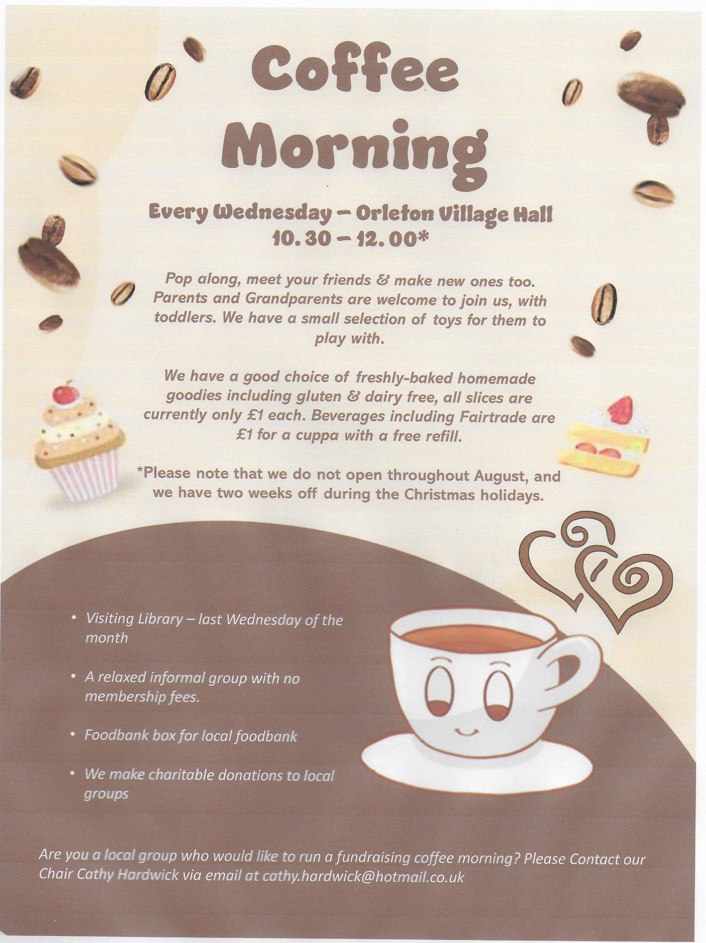

**Folk at the Boot**

Not just folk but all genres

of music

Performers always welcome



It's always 2nd Thursday of the month at 8.00pm

We had the pleasure of welcoming Nigel Gibbons as our speaker in October; he is a Blood Biker in the Shropshire, Staffordshire and Cheshire Blood Bikes (SSCBB) team. All the Blood Bikers are volunteers who have passed the Institute of Advanced Motorcyclist (IAM) test to ensure their safety on the road. Some of the bikes have names in memory of loved ones who have benefitted from this vital service.

The Blood Bikers provide a free urgent delivery service to hospitals, hospices, blood banks, milk banks and a range of NHS departments, carrying a variety of items from blood samples to medical notes, medicines, prescriptions, frozen breast milk and faecal matter. Sometimes they work in relays with other Blood Bike teams across the UK ensuring delivery is quick and efficient.

The SSCBB also have four cars which are used as back up, particularly when the temperature outside is less than two degrees. Their running costs are all met by donations - £119k per year is needed just for the bikes.

As usual, Evergreens gave a donation to our speaker; we also raised an amazing £140 from personal donations.

Anyone in the 50+ age group is welcome to join us on the last Thursday in the month; our Christmas Lunch is on 11th December at The Fountain, Oldwood, Tenbury Wells, 12 for 12:30pm; menu choices and payment (£25 two courses, £29 three courses) by 1st December please.

For further information contact Sue Turner: 01584 831324, sue.a.turner@gmail.com







**Your**

**Advertisement**

**Here**

Only £15 for twelve months

Half page only £20

Send copy to:

**Orletonmagazine@gmail.com**



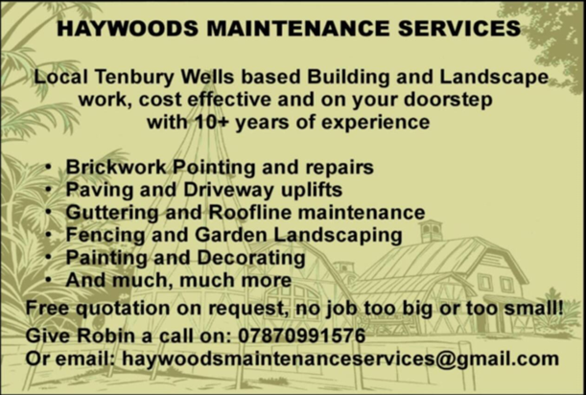

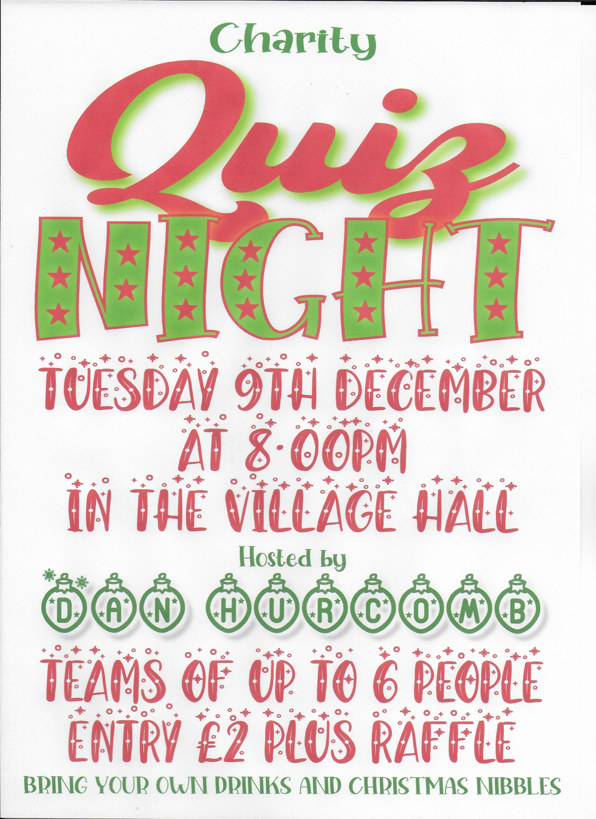

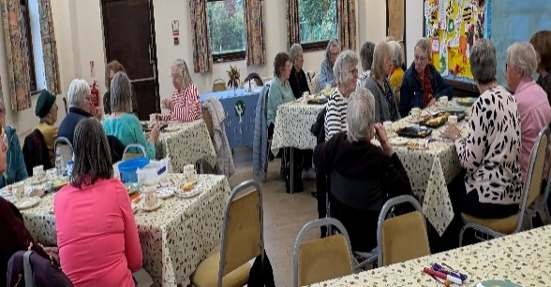**Orleton WI**

Orleton WI meets on the second Monday of every month (except August) in Orleton Village Hall –

2:30pm in Autumn and Winter,

7:30pm in Spring and Summer.

Visitors are always welcome.

Our speakers cover a wide range of topics; and our future programme includes a hands on decoupage workshop led by our President Sue Copson; a talk with Amy Johnson from St Michael’s Hospice.

Our AGM in April will include a local cheese and wine tasting.

In November Orleton WI provided refreshments at the Handmade & Gift Fair, and we are also taking part in the Stars & Angels event at the Church in December. We are very much part of the community!

If you would like further information,please contact our President, Sue Copson on

01568 780956 or [susancopson934@gmail.com](mailto:susancopson934@gmail.com)

Quarry Farm Shop

**We are providing what you really want…**

**Additive Free Meat**

**Meat as it used to be produced**

**We use traditional methods to produce what can**

**only be called real meat.**

**Between Leominster & Luston on the B4361**

**Telephone 01568 613156**

**Email:sales@quarryfarmshop.co.uk**

**Richard@quarryfarmshop.eclipse.co.uk**

**Safer Neighbourhood Team**

Leominster Safer Neighbourhood team have had a busy few weeks, not only with community events and surgeries, but also with incidents happening on our patch.

We carried out a joint operation with animal welfare and community protection officers from Herefordshire council, stopping agricultural and livestock vehicles to check vehicle and animal documentation. We also looked in vans and picks ups for any rogue trader evidence, such as unlicensed waste or stolen tools etc. We also spoke to a couple of drivers about unsafe loads. We have also carried out a partnership operation with immigration, Hereford and Worcester Fire Service and licensing officers from

Herefordshire Council. The details of this operation will be published by our corporate communications team in due course, but I can say it was successful.

Crime prevention. As we are entering the winter months, make sure you leave a light on when leaving the property in the hours of darkness. A small timer switch is only a couple of pounds from the internet. If you are going to be away from the property, ask a friend or neighbour to keep an eye on it for you.

If you see anything suspicious please contact 999/101.

If you have any questions or queries for Leominster Safer Neighbourhood team, please contact us at [leominster.snt@westmercia.police.uk](mailto:leominster.snt@westmercia.police.uk)

**Boot Inn**

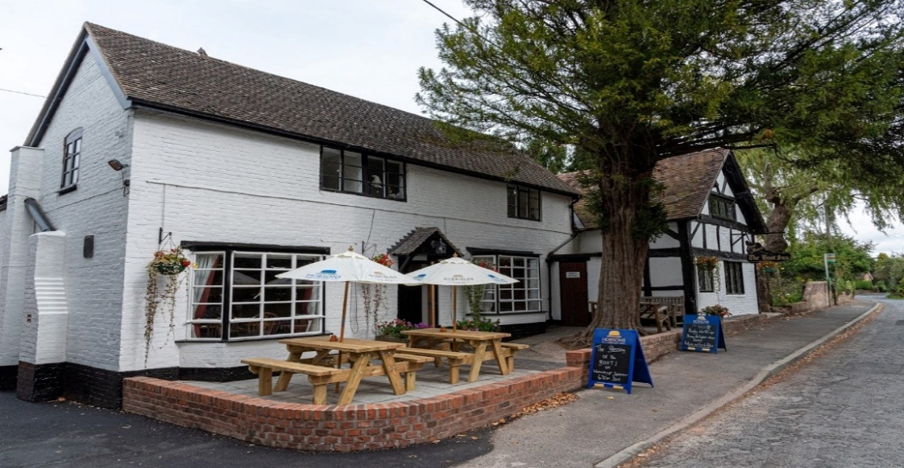

**Offers:**

· **a fine dining menu using the best seasonal produce in its atmospheric beamed dining room**

· **a wide selection of wines**

· **a range of real ales, ciders and craft gins and other spirits**

**Large Beer Garden with Pergolas**

**Large Car Park at rear**

**Reservations: 01568 780228**

**Traditional 16th**

**Century timbered inn, now owned by the local Orleton Community.**

**Orleton Charity Quiz Nights**

**Teams of up to six members. 7.30 for a 8.00pm start**

**Pre-booking of tables at:**

**the Boot (01568 780228) and the Maidenhead (01584 831686)**

**is strongly advised**



April 14th Maidenhead

May 12th Boot Inn

June 9th Village Hall

December 9th Village Hall

January 13th Maidenhead

February 10th Boot Inn

March 10th Village Hall

**All proceeds go to support local organisations in Orleton Village or**

**recognised National Charities.**

**Special Event: John Robbins Memorial Quiz at Orleton Village Hall**

**on a Saturday evening. Watch for the date!**



**Report from your County Councillor**

**Dan Hurcomb**

**I am glad to report that after expressing my frustrations for two and a half years over the state of the road markings on the B4362 / B4361 between Mortimers Cross and the A49, the Council has finally agreed to repaint those areas which were not resurfaced this year. As part of this they have also agreed to resurface 250m from Mortimers Cross Junction back towards Lucton. I have challenged them to go further and at the very least undertake patching works on the worst bits before you reach the turn to Lucton. I am pleased to say they have agreed to increase the scope of the works to include some of the area proposed. The work is due to start on the 24th November so by the time you read this it may well have been completed.**

**In last months column I wrote about the financial situation Herefordshire Council was facing due to the government funding review and rising demand for temporary accommodation and adult social care services (amongst other things). The chancellor’s budget at the end of November and the publication of the Draft Local Government Finance Settlement in December will bring greater clarity to the situation and I will of course update you in the next edition of this Magazine.**

**In May 2026 I will have been your ward councillor for three years. Over that time we have made significant progress on the local highway network (and yes there will always be more to do!), road safety and flooding. On that score, I am pleased that further improvements to the B4361 / Ashley Moor Junction are planned in the new year with**

**reprofiling of the verge and a relocation of the BT pole currently planned. I can also report that the flood alleviation proposals continue to gain momentum and I thank those local landowners and residents who are supporting this activity.**

**Finally, I was unable to attend the Remembrance Sunday service in Orleton as I was attending the service in Kingsland instead. It is important that we continue to recognise and remember the sacrifice of so many for the freedoms we currently enjoy. On a related note, thanks are due to the Parish Council for ensuring the village was tidied and swept prior to Remembrance Sunday.**

**As always if you have any concerns, issues or would just like a chat then please do get in touch. It only remains to say, Merry Christmas and to wish you and yours a happy and prosperous new year.**

**Dan Hurcomb**

[**dan.hurcomb@herefordshire.gov.uk**](mailto:dan.hurcomb@herefordshire.gov.uk)

**07837726821**

**ORLETON FOOTPATH MAINTENANCE VOLUNTEERS**

For those of you who live around Orleton you will have seen our handiwork…the refurbished red telephone box, the refurbished street signs, the galvanised fully opening pedestrian gates that we’ve fitted on a lot of our local footpaths to make it easier to get out and about.

We’re a group of volunteers male female from a variety of backgrounds who enjoy being out in our lovely countryside, doing practical stuff, and having fun while we are doing it.

We all help each other and are learning new skills as we go.

We got going in 2023 and have undertaken repairs and replacements of stiles, of fingerpost direction markers, field waymarkers, clearing of overgrowth, installed flights of wooden step plus the refurbished the red phone box and street signs.

We have done this work in over 40 different locations mostly in and around Orleton.

Our main time is spent looking after Public Rights of Way which are the field footpaths and bridleways.

If any ladies or gentlemen fancy joining us/seeing what we do please get in touch with Martin Bradford at emlmart@hotmail.com

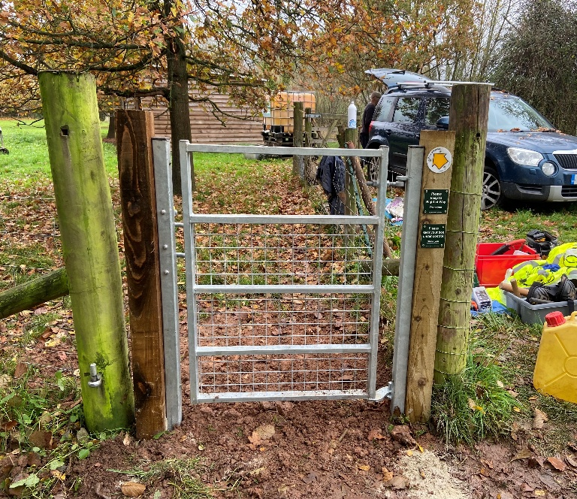

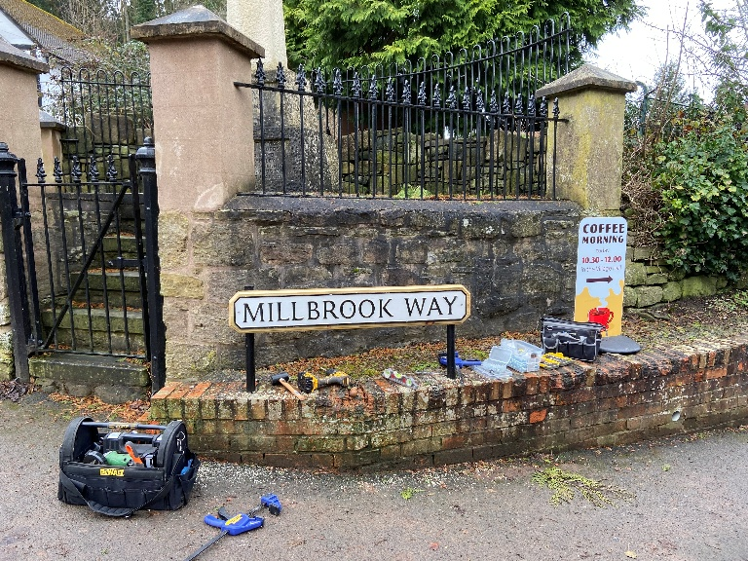

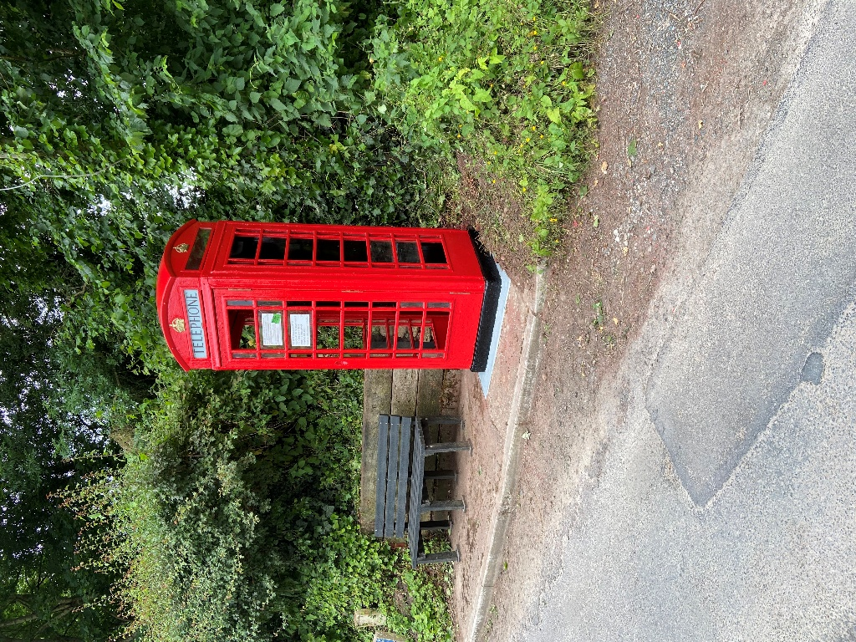

Motorhomes to return for the New Year

Members of the Van Club whose Rally was held in Orleton last June, are to return to see in the New Year at Orleton Village Hall.

Club Secretary, Christa, commented that members had received a warm reception in our Village Shop and two pubs, and even had residents greet them as they walked through the village. Their visit had been most enjoyable as they felt welcomed.

They had found Orleton most attractive with its ancient church and black and white buildings. The bus service to Leominster and Ludlow enabled them to leave their vehicles on site and visit these towns.

Orleton was an ideal location and they have already made a reservation for next May.



Photo below: June’s Country & Western Night in Orleton Village Hall

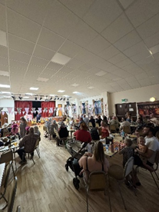



Let’s Beat the Scammers

Reports of Courier Fraud incidents continue to be prevalent in our region and the public need to aware of this method used by Fraudsters to defraud their victims. Courier Fraud occurs when a fraudster contacts victims by telephone usually claiming to be a police officer, bank official or other law enforcement official. The caller may also be able to confirm some easily obtainable basic details about the victim such as their full name and address. The caller will try and build up trust with the potential victim before proceeding. Their aim is to get the victim to reveal their PIN, credit or debit card and /or bank details, and more than often will target the elderly as potential victims.

There are reports of a resurgence in WhatsApp scam messages, which contain dodgy links that lead to malware being downloaded onto your device. It begins with a WhatsApp message promoting a sham version of the messaging service called 'WhatsApp Gold,' which has special features that can be unlocked by clicking a link. This link will lead to malware being downloaded to your device. Another version of this scam features a message which warns of a video called 'Martinelli' installing malware to your device if opened. However, there is no evidence that this video exists. You can report a WhatsApp message by selecting it in your conversation and tapping ‘report’. To report the sender on WhatsApp, open up the chat, tap on the sender's contact details and select 'block and report'. Whether it's the 'Hi Mum and Dad' scam, fake job offers or even an account takeover scam, WhatsApp also enables people to call contacts and use video, audio and images in messages. These features are sometimes exploited by fraudsters who impersonate brands, friends and family members in convincing scam messages in an attempt to con you out of your money. If you haven't done so already, add an extra layer of security to your WhatAspp by setting up two step verification (2SV).

FAKE GIVEAWAY SCAM MESSAGES

A scam message impersonating M&S offering vouchers and free products regularly circulate on WhatsApp. They typically take you to a malicious website and ask you to complete a survey before attempting to gain your personal and financial information to ‘post your prize’. The messages often also ask you to reshare the message to a number of your WhatsApp contacts, to keep the scam spreading.

Tip: never trust an offer that is too good to be true and avoid clicking on links in text messages.

Exclusive Groups can also be scammed Fraudsters have exploited WhatsApp's ability to allow you to create groups featuring up to 1024 members to groom potential victims into scams. Dodgy investment scam adverts lead to WhatsApp groups where you’re given free ‘stock trading advice’ for weeks before being asked to pay for this guidance. Action Fraud has warned of the use of WhatsApp groups by fraudsters. This is through scammers infiltrating existing groups by calling a member of the group pretending to be a genuine member themselves using a fake profile picture. During the call, the scammer will say that they’re sending over a one-time passcode to allow them to join an upcoming video call for group members. After this, the fraudster will ask them to share this passcode so they can be ‘registered’ for the video call. However, if the scammers are given this code, they’ll be able to take over the victim’s account to impersonate them and scam other members of the group.

Tip: there are lots of ways someone could have got your number to add you to an 'exclusive' group, this doesn't mean their intentions are genuine and you should be wary of any unsolicited messages.

Finally if you have fallen for fraud. Report it to Action Fraud on 0300 123 2040 or via actionfraud.police.uk

Stay Alert, Be Aware,

Protect your money.

**Mortimer Medical Practice**

**Total Triage**

The introduction of Anima online consultation and the move to Total Triage has been a major change in how the Practice operates. As expected, there have been a few teething problems, but the system seems to be settling in well. The Practice has received many positive comments and helpful feedback, which is being used to continue improving the service.

The Patient Participation Group (PPG) has been working hard to provide ongoing support during the transitional period, and thanks are also due to the Friends of Mortimer Medical Practice Charity for funding the iPads now available in each surgery. These iPads can be used by patients to fill in their Anima forms, with assistance from the Reception Team if needed.

**Practice News**

This month, the Practice bids a fond farewell to Dr Verity Jones (Oloro) and Mrs Jackie Hodnett, who is retiring after an incredible 34 years of service at the Practice. We wish them both every success and happiness in their next adventures. At the same time, the Practice is delighted to welcome several new members to the team: Sharon and Amanda in Dispensary, as well as Kim, Raighan and Millie on Reception.

**Building Work**

Building work is currently underway at the Kingsland surgery to create a new consultation room. As the Practice continues to grow, this expansion will help meet increasing demand and continue providing high-quality care for patients.

**Practice Training Afternoons**

Please note that the Practice and Dispensaries will be closed from 12:00pm on the following afternoons in 2026 for essential and mandatory staff training:

* Wednesday 14 January 2026
* Thursday 16 April 2026
* Tuesday 14 July 2026
* Wednesday 14 October 2026

For urgent care during these times, please call Reception on 01568 708214 before 6:30pm. After 6:30pm until 8:00am the next morning, call NHS 111 for medical advice or assistance.

**Flu and COVID Vaccinations**



It’s not too late to book your flu and COVID vaccinations. Please call Reception on 01568 708214 to make an appointment and stay safe and well this winter.

The next PPG meeting is on January 21, 2026. In the meantime, if you have any issues or concerns, please contact Kate Best on 07740 177370 or Sue Plant on 01584 831105.

**Orleton History Group Update**

Our October event on the History of (Parish) Church Music was a fascinating exploration of the history of music in the Parish Church. Did you know that churches had organs before the Reformation, and that most then lost them and didn’t regain them until the Victorian period? Read our detailed report on the History Group pages at www.stgeorgesorleton.org.uk. Our November talk on 900 Years of Faith has yet to take place as I write.

You can also find our series of studies into the lives of the men named on the War Memorial, either in folders in the Church or at the History Group pages on the website: www.stgeorgesorleton.org.uk

Our upcoming talks & events are below. The talks are all free, donations invited for refreshments & heating.

**Saturday 13th December, 7.30pm, St George’s Church: From Minced Meat to Mincemeat, the strange story of the mince pie, accompanied with Christmas wines from across the ages**: sample a range of mince pies from across the ages, starting with the original savoury minced meat pies and ending with our current sweet pies; all washed down with some of the choicest wines of the age! To allow us to cater (and purchase wines) for appropriate numbers, this is a ticketed event. Tickets £5 if purchased by Sunday 8th December from the Village Shop. £8 if purchased on 9th December or later.

**Saturday 24th January, 2.30pm, St George’s Church: Bitten by Pigs and Struck by Lightning: How Coroners' Rolls can Expand our Knowledge of Life in the Late Middle Ages'.** The role of the Coroner was introduced in England in 1194, and it was his role to investigate all deaths that occurred in unusual or suspicious circumstances, as well as any deaths that occurred in prison. These investigations or 'inquests' were recorded, and a considerable number still survive. The description of each death provides a snapshot of how people were living at that time, offering a rare insight into life in the Late Middle Ages.

**Saturday 28th February, 2.30pm, St George’s Church: “Bongs in the Belfry": How St George's bell keeps us on time , hour by hour.** Terry Tandler, with Len Vidler, will tell us the fascinating story of St George’s bells.

You can also read reports on previous talks at the history group page at: [www.stgeorgesorleton.org.uk](http://www.stgeorgesorleton.org.uk) (and then click on ‘Orleton History Group’).

If you would like further information about the group, please contact Liz Mackay on

**e.e.mackay@gmail.com, or 07484 679671.**



.

Orleton Young Farmer’s Club

Orleton Young Farmers’ Club is delighted to share an update on a vibrant and eventful few months, marked by new leadership, successful competitions, growing membership, and strong community spirit.

**New Committee Appointed at September AGM**

September saw the club begin its new year with the Annual General Meeting, where a fresh committee was elected.

* **Chairman:** Bell Beaumont
* **President:** Jonathan Crofts
* **Secretaries:** Alisha & Jess Davidson

The club extends thanks to outgoing committee members and looks forward to an exciting year ahead under the new leadership.

**Ploughing Match Success**

Also in September, members took part in the annual Ploughing Match. The day brought good competitions, a few prize cards making their way back to Orleton YFC, and even some ploughing managed to take place! The event was enjoyed by all and highlighted the club’s continued enthusiasm for traditional agricultural skills.

**October: New Members and Club Competitions**

October kicked off with a lively New Members’ Evening, a fun-filled event that welcomed six new members into the club. It was a fantastic opportunity for potential members to meet the team and get a taste of what Young Farmers is all about.

The club was also proud to have juniors taking part in the Junior Quiz competition, showing great enthusiasm and strong entries from our younger members.

Rounding off the month, members embraced the Halloween spirit with a pumpkin carving night. The creativity on display was outstanding, with some truly impressive and imaginative artworks produced.

**November Bonfire Draws 1,400 Visitors and Supports Local Causes**

November brought the club’s biggest event of the year - the Orleton Bonfire Night, held in the centre of the village. An incredible 1,400 people attended, making it one of our most successful bonfire celebrations to date.

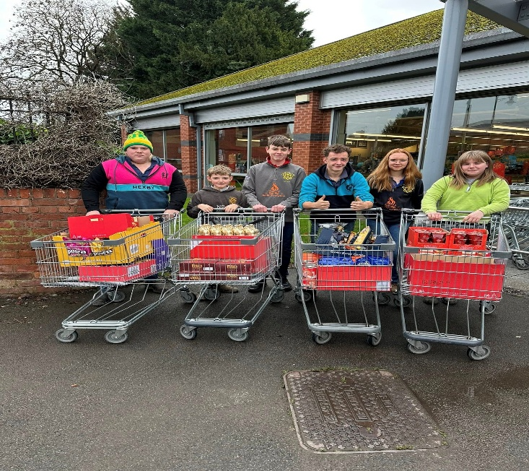

Generosity from the community allowed Orleton YFC to support several local charities and groups. Donations included:

**£250** to *Luctonians Charity Group Food Bank Collection*

**£500** to *Orleton and District Junior Football Club*

**£500** to *Orleton Recreation Association*

The club extends heartfelt thanks to everyone who helped, attended, or supported the event in any way.

**Looking Ahead**

Orleton YFC is excited for the festive season and winter months ahead. Iin late November, members will once again have organised the Christmas Light-Up Tractor Run, proudly helping to kick off the Ludlow Christmas Light Switch-On. This popular event always brings festive cheer and showcases the club’s creativity and community spirit: Iin December, members will be rolling up their sleeves for an important environmental project: planting a new hedge on the recreation ground in Orleton, beside the bonfire field. This will support local wildlife, enhance the area, and leave a lasting positive impact on the village.

With such a strong start to the year, Orleton YFC remains committed to providing opportunities for young people in the community to learn new skills, build friendships, and support local causes.

For more information or to get involved, please contact Orleton YFC through our social channels or speak to any committee member.

**ORLETON AND DISTRICT GARDENING CLUB**



**STONE SOUP**

 On 28th October ODGC welcomed back Kevin Alviti. No stranger to the club Kevin lives on a five acre smallholding with his wife and three children. He has fifty two vegetable beds, an orchard and coppice and keeps chickens and bees. He is a carpenter and craftsman, a scoutmaster and contributes articles to woodworking magazines as well as giving gardening talks.

Following time honoured tradition Kevin began with ‘Once upon a time…’ recounting the story of an old man who, arriving in a village at nightfall, told the locals that he was going to make stone soup for supper. Drawing a silk purse from his pocket he slipped a stone from it into a pan of boiling water. Intrigued the villagers gathered round and each was gently persuaded to contribute an ingredient to add to the pot thus creating a delicious soup. The moral being that the magic ingredient was not the stone but the communal effort and variety of ingredients.

Modern diet is largely derived from thirty or so ingredients available in supermarkets. Kevin showed us that we can make tasty and nutritious meals from plants from our own gardens which otherwise would be composted. He makes a delicious soup from young nettle leaves in Spring and stock from the pods of broad beans and peas. Broad bean tops are steamed and served with butter.

Butter makes ingredients go a long way and is good with wild garlic. Kevin makes a tasty supper from tomato leaf pesto, crushed garlic, olive oil, cider vinegar, toasted salted peanuts and crispy bacon served with pasta. Pea tendrils and leaves are good in salads. Soup can be made from the leaves, growing tips and blossoms of squash cooked with garlic, basil, mushrooms and crispy pork fat.

Elderflower blossoms coated in a light tempura batter and cooked in butter make a delicious pudding dredged with icing sugar. The early leaves of blackcurrants are used to make cordial and herbal teas can be made from the leaves of Sweet Cicely, nettle and mint. Haws are stewed then sieved and mixed with fifty percent of apples to make a fruit leather. Windfall apples are cooked to provide pectin and unripe plums are combined with sugar to make cheong.

Adding the proviso that correct plant identification is crucial Kevin demonstrated that with a little ingenuity, instead of a stone, tasty and unusual meals can be made to enliven the modern diet.

***Ghislaine Arundal*e**

There will be no talk during December.Club members who have booked are looking forwards to their their annual Christmas meal at The Riverside Aymestreyon December 9th. Details of the 2026 programme will be posted on our website in due course.

[**www.orletongardeningclub.co.uk**](http://www.orletongardeningclub.co.uk/)**.**

**Doors open 7.15pm for 8pm start. Non-members welcome at £2.50 per person which includes tea or coffee.**

**Annual Membership £15.0**

[**www.orletongardeningclub.co.uk**](http://www.orletongardeningclub.co.uk)

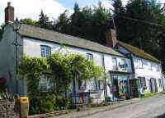

Orleton Village Shop

& Post Office

Shop Post Office

Mon- Fri 0745-1800 0745-1800

Sat 0830-1230 0830-1230

Sun 0830-1230 Closed

Foundations Excavations

Site clearance Concrete work

**Edward Royle**

**JCB Hire**

**All types of groundwork**

Small jobs undertaken

01584 831418

07890 136426

Concrete breaking

Drainage/Septic tanks Driveways/pools

**Debbie Gates**

**07966 061205**

**Professional Painting & Decorating**

**Interior & Exterior**

**Airless Spraying**



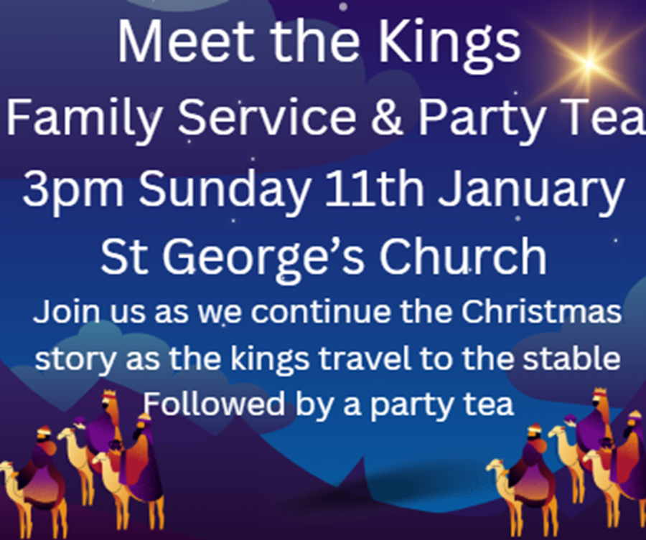



**Giving Thanks for the Birth of a Baby**

This is the season to be thankful for the birth of children! As we celebrate Jesus’s birth, it is a good time to ask the question: would you like to give thanks for the birth of a baby in your family, without the commitment of Baptism.

This is something that we can offer at St George’s.

On 9th November, we were delighted to celebrate our first Thanksgiving Service for the birth of a baby. It was a lovely occasion, enjoyed by all.

If you’re interested in a Thanksgiving Service for the Birth of a Baby in your family, please get in touch at: orletonstgeorges@gmail.com

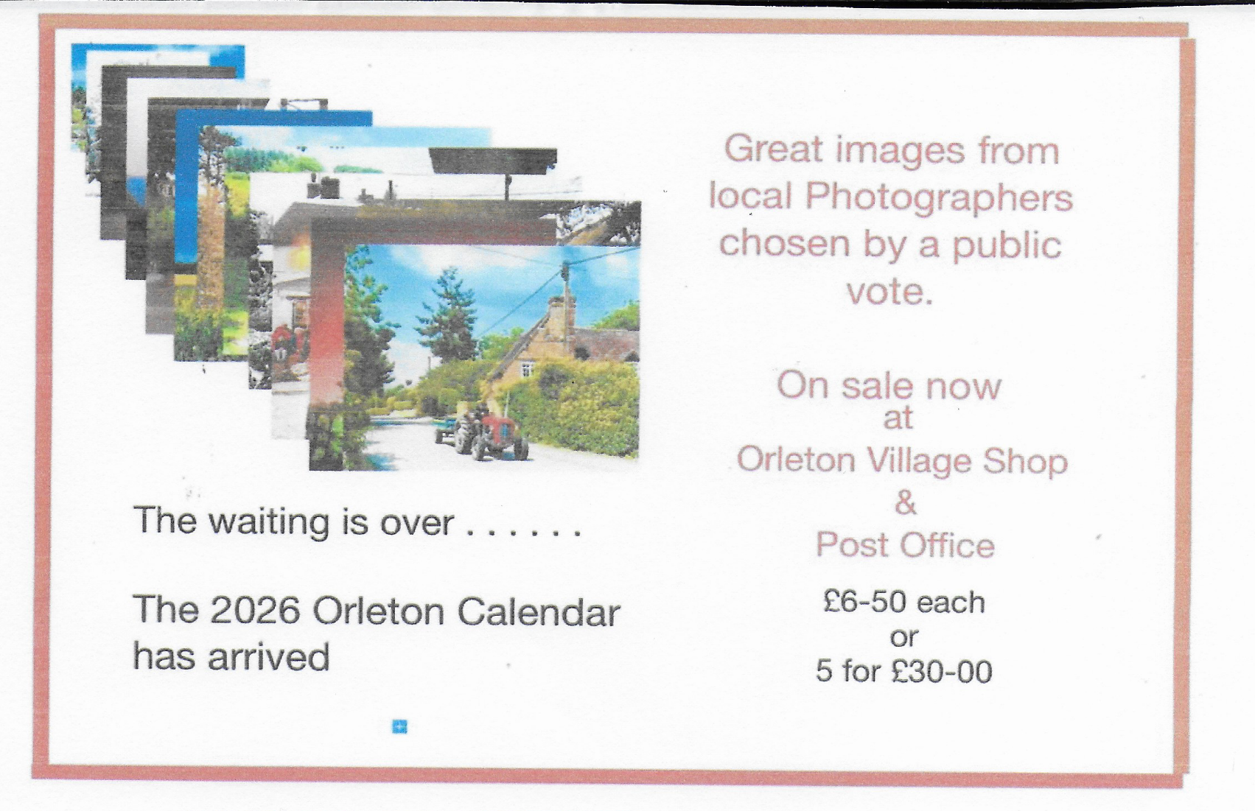

Orleton Church & Chapel News

Unsurprisingly, Christmas is a busy time of year for St George’s and the Place-holder for picture Barry has to include Chapel. Our Christmas services can be found below. All are very welcome to come to any or all of them. We are also delighted to once again be working with the Recreation Association and Village Hall on the return of the Stars & Angels Festival, on 6th December at St George’s, 11am-4pm. Come along to see beautiful displays, try out a range of crafts, visit Santa, and see a Lego Christmas village. Our other Christmas social event is an event being put on jointly by the Orleton History Group and the St George’s Community Association: on Saturday 13th December at 7.30pm in St George’s, we explore: From Mince Meat to Minced Meat: sample mince pies made using recipes from across the centuries, alongside some of the choicest wines of the age! Tickets need to be bought in advance from the Village Shop - £5 up to 8th December, and £8 from 9th December onwards. Updates on our other activities, including a report on the Remembrance services, an update on our Family Services, the Orleton History Group, Singing for Fun, Caring for God’s Acre, food bank donations, and the 100 Club winners, can be found in our full newsletter, at: https://stgeorgesorleton.org.uk/news/news , and click on ‘Church & Chapel News’.

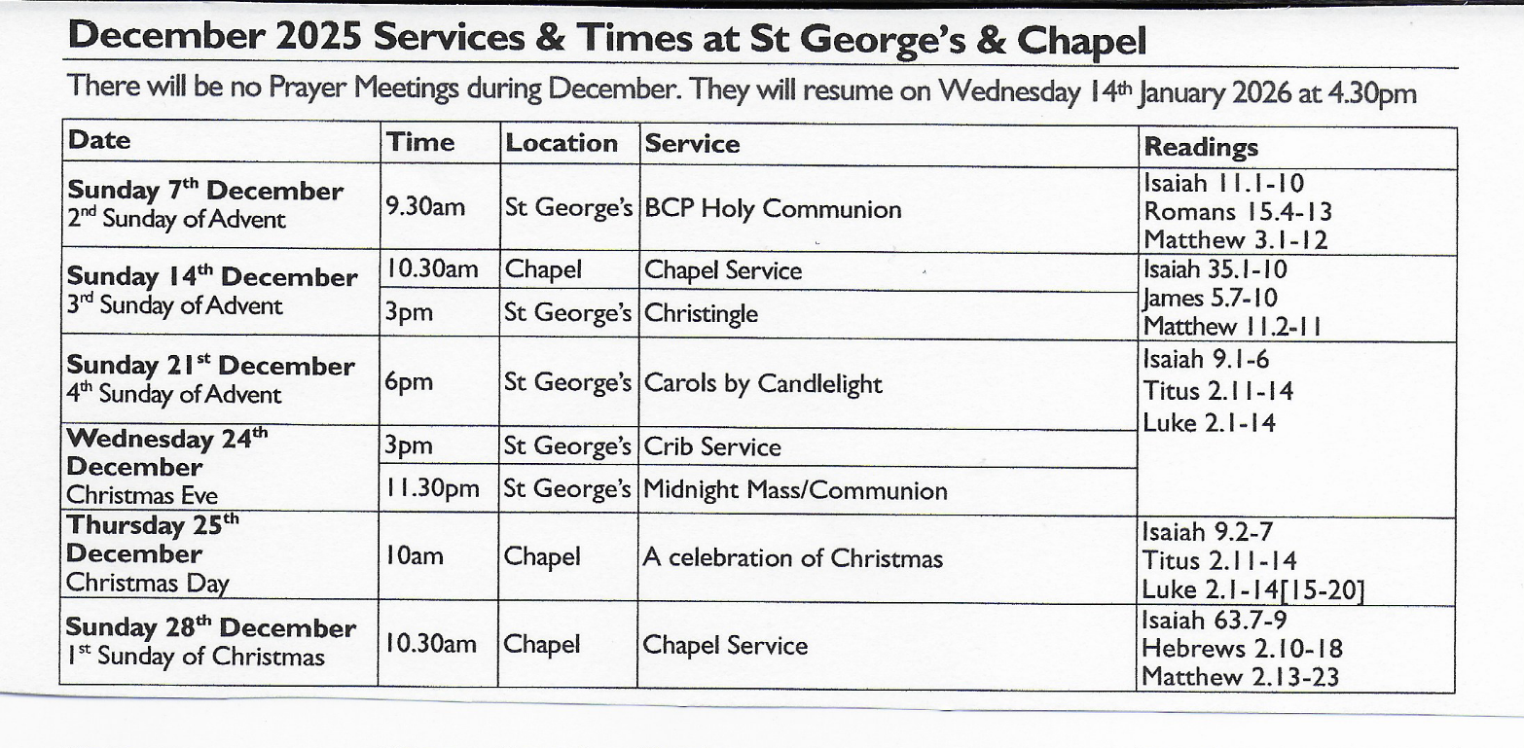

Further information

For further information about Church, Chapel, services or activities, or if you would like to get

involved either socially or as a member of the congregation then please contact:

Matthew Burns (Vicar, St George’s): 01568 614399,

teamvicarwest@leominsterteam.org.uk

Rev Denise Hargreaves (Methodist Minister): 01584 318628, dkah26@gmail.com, Ludlow Church

Office 01584 879233

Also, why not check out the St George’s website: https://stgeorgesorleton.org.uk/

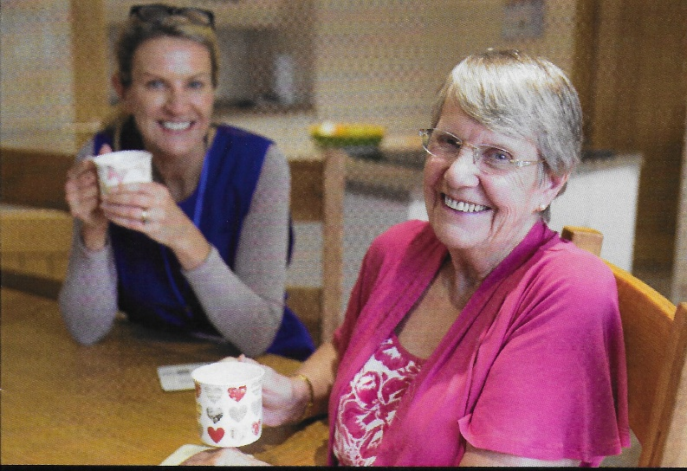

Orleton Good Neighbour Scheme

The Good Neighbour Scheme supports our community using a team of volunteers to help people who are experiencing difficulty in their own homes essentially, by just doing things that good neighbours do for each other.

Examples of how the scheme can help:

* Fetching prescriptions
* Occasional lifts to the surgery or hospital
* Shopping and running errands, such as posting a letter.
* Practical tasks around the home, such as changing a light bulb or hanging a picture

**Contact Number 07467 535503**

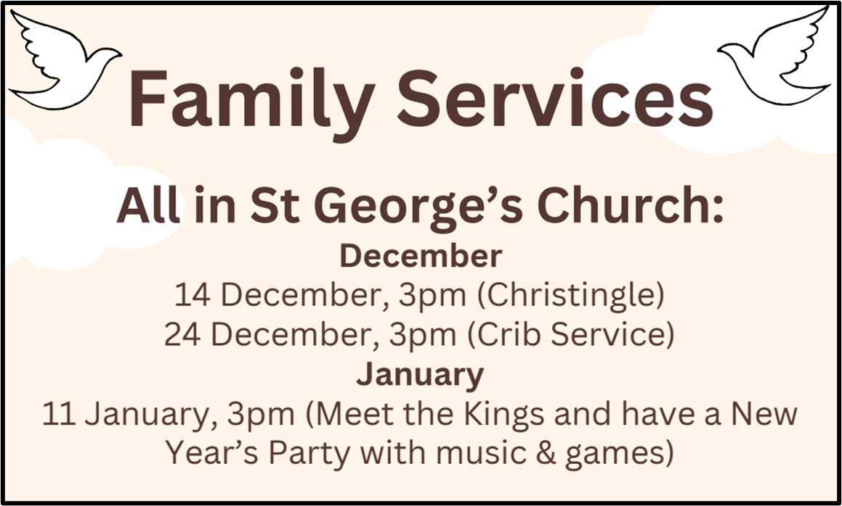

Orleton Short Mat Bowling Club

Why not come and join us on Tuesday afternoons 2.00 – 4.00 pm at Orleton Village Hall from September through to April. We are a small group meeting each week for a friendly game and the opportunity to socialize.

If you think you might be interested please come along and see what the game is all

about. We operate on a pay as you go basis, two games during the afternoon with a

refreshment break half way.

Everyone is welcome , whether you have played before or would like to learn please

come along support us and the Village Hall.

We have lots of space available, unfortunately numbers have dwindled this season and we really do wish to keep this group open

.

For any further information please contact:

David or Sue Copson 01568 780956 susancopson 934@gmail.com



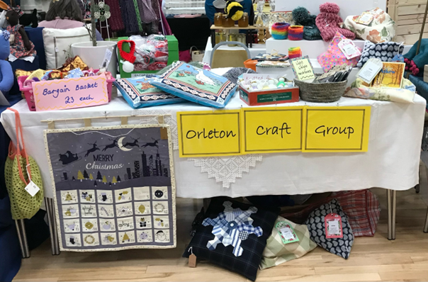**Orleton Craft Gro** **up**

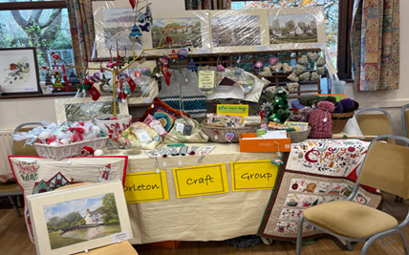

This was our amazing stall at the Handmade & Gift Fair on 15th November, such a variety of items, all original and handmade.

Our Craft Group lunch will be in January, date and venue to be confirmed; we usually meet

on the first and third Thursday afternoons at Orleton Village Small Hall, although we only meet the once in December on the 4th, 1:30 to 4:30 and in January 2026 there is a slight change - we will meet on 8th & 22nd.

Visitors are always assured of a warm welcome. Come and join us with your chosen craft and enjoy tea, cake and a chat along the way.

Further information contact: [sue.a.turner@gmail.com](mailto:sue.a.turner@gmail.com) 07840 023856

**Victoria Allen Funeral Services**

An independent Family Business

Over 25 years of experience

Competitively price

Private Chapel of Rest

Golden Charter pre-paid Funeral Plans

Home visits available

24 hour service

01584 870935

Email: vafs@btinternet.com

9 Charlton Rise, Ludlow, SY8 1ND

www.vallenfuneralservicesludlow.co.uk

[Grab your reader’s attention with a great quote from the document or use this space to emphasize a key point. To place this text box anywhere on the page, just drag it.]



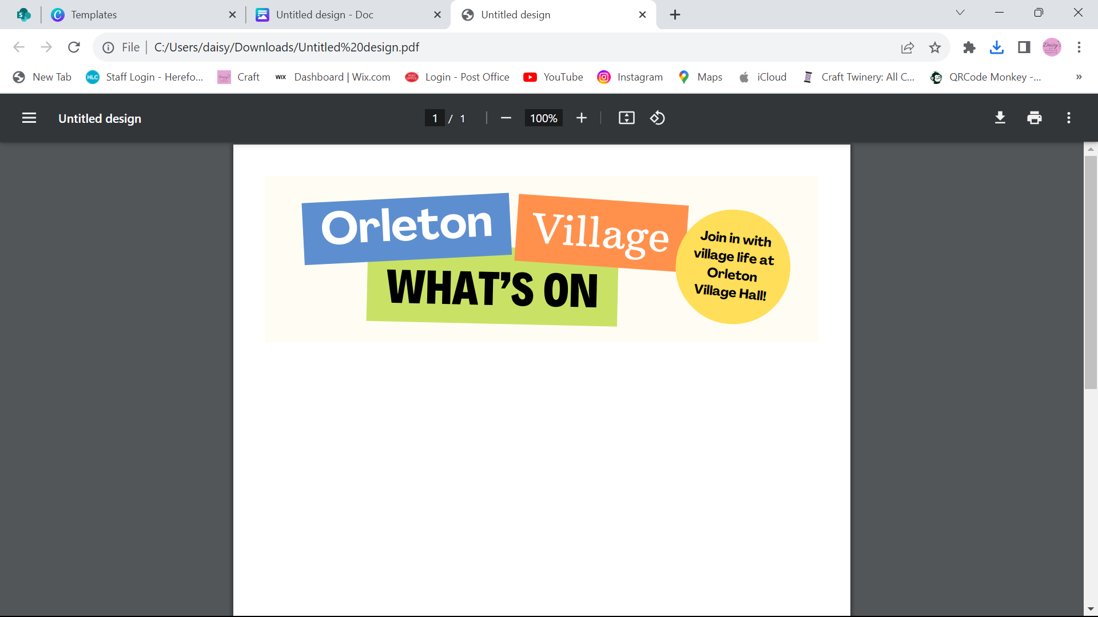

**COMING UP… (All events are in Orleton Village Hall unless stated otherwise)**

**Saturday 6th December** – **Stars & Angels Festival 11am-4pm** – St Georges Church (See poster for details)

**Tuesday 9th December** – Quiz Night 8.00pm at Orleton Village Hall 8pm - £2 entry plus Raffle

**Dates for your diary…**

**Saturday 7th March** – Ludlow Concert Band return to the Village Hall

**The REGULARS Monday – Thursday …**

**Orleton Toddlers** Every Monday morning 10-11:45am

Contact: Bethan 07534 726222 or Charlotte 07964 981036

**Orleton WI** 2nd Monday of the month, October to March at 2:30pm

Contact: Sue Copson [susancopson934@gmail.com](mailto:susancopson934@gmail.com)

**Tai Chi** Every Tuesday 10:15-11:15am Contact: Rose

**Bowling Club**  Every Tuesday at 2pm

Contact: Sue Copson [susancopson934@gmail.net](mailto:susancopson934@gmail.net)

**Rainbows** Every Tuesday in term time 4:30-5:30pm

Contact Kaye Harrison [kayemharrison@yahoo.co.uk](mailto:kayemharrison@yahoo.co.uk)

**Gardening Club** Last Tuesday of the month 7:30-9:30pm

Contact: Monica 01568 613361 [orletongc@hotmail.co.uk](mailto:orletongc@hotmail.co.uk)

**Yoga** Every Tuesday evening 6:30-7:30pm (Commences again in September)

Contact Rosie 07834 851656

**Coffee Morning** Every Wednesday at 10:30am-12:00 (Closed in August)

Contact: Cathy Hardwick [cathy.hardwick@hotmail.co.uk](mailto:cathy.hardwick@hotmail.co.uk)

**Library**  Last Wednesday of the month at Coffee Morning 10:30-11:45am

Contact: Sue Rogers 01584 831514

**Sequence Dancing** 3rd Wednesday of the month – 2-3pm

Contact: Amy Whitby [amyelwynwhitby@gmail.com](mailto:amyelwynwhitby@gmail.com)

**Evergreens** Last Thursday of the month – 2-4pm

Contact: Sue Turner [sue.a.turner@gmail.com](mailto:sue.a.turner@gmail.com)

**Craft Group** 1st and 3rd Thursday of each month 1:30-4:30pm (No sessions in August)

Contact Sue Turner 01584 831324 [sue.a.turner@gmail.com](mailto:sue.a.turner@gmail.com)

**Table Tennis** Every Thursday at 7:30pm

Contact: Geoff Lewin [geoffnlewin@gmail.com](mailto:geoffnlewin@gmail.com)

**Hall available for private bookings**

**Contact Barry Gandy 01568 780583 or** [**bookings@orletonvillage.co.uk**](mailto:bookings@orletonvillage.co.uk)

**To include your event or amend an entry in the Dairy,**

**Please Email** [**orletonhandmade@gmail.com**](mailto:orletonhandmade@gmail.com) **by the 12th of the month**

All entries are, as far as we know, correct at the time of going to print.

Free

Ladies folding Bicycle

Three speed

Easy fit into car boot

Tel: 01568 780583



**Grafted Apple Trees**

**Discovery, Ashmeads. Russets and more**

**Three year old Dessert. Cooking and Cider varieties in pots for easy care until you decide where to plant**

**Root Stocks:**

* **M25 Vigorous**
* **M111 & M106 Semi Vigorous**

**Advice on tree and orchard management also provided**

**Contact Chris:01584 831195**

**Waterloo Farm, Orleton Common,**

**www.applewoodcourses.com**

Order your

**Orleton 2026 Calendar** now!

The Calendar, featuring the winning entries from the Village Photographic Competition is now in production and will be available at a cost of £6.50.

Now available at Village Shop & Post Office

**IMS Brickwork**

**We have built a solid reputation for**

**professional, reliable, clean and insured construction**

**Patios, General Brickwork, BBQs Shed Bases, Raised Beds, Repointing**

**Tel: 07840 367845**

**iansimcox@imsbrickwork.com**

**www.imsbrickwork.com**

**Contacts**

|  |  |  |  |
| --- | --- | --- | --- |
| Adopt a Footpath Group | Martin Bradford | emimart@hotmail.com | 01568 780151 |
| Allotments Assoc | Nick Ford |  | 01584 875834 |
| Art Group | Geoff Trotter | Geoffrey.a.trotter@gmail.com |  |
| Caring for God’ Little Acre | Barbara Mark |  | 01568 780842 |
| Church Wardens | Liz Mackay  John Berry |  | 07484 679671  01568 780321 |
| Cubs | Lisa Davies |  | 01584 831356 |
| Dance Fit | Pauline Woodward |  | 01568 780950 |
| Doctors |  |  | 01584 831300 |
| Evergreens | Sue Turner |  | 01584 831324 |
| Gardening Club | Nick Russel |  | 01568 780678 |
| Good Neighbour Scheme |  |  | 07467 535503 |
| Herefordshire Councillor | Cllr. Dan Hurcomb | dan.hurcomb@herefordshire.gov.uk | 07792 882147 |
| Land Drainage Group | David Lane |  | 01568 78036 |
| Orleton Relief in Need | Barry Rogers |  | 01584 831514 |
| Orleton Junior Football Club | Mel Williams | cherry.brook@me.com | 07511 920515 |
| Orleton Todlers | Bethan Jenkins | bethan.i.edwards@hotmail.co.uk | 07534 726222 |
| Orleton Young Farmers Club | Bell Beaumont | orleyonyfc@hotmail.com |  |
| Parish Council |  | clerk@orleton-pc.gov.uk |  |
| Pre-School | Tara Morris |  | 01568 780143 |
| Primary School |  |  | 01568 780366 |
| Primary School PTA | Nicola Goodman | nicolagoodman1989@gmail.com |  |
| Rainbows | Carly Morgan |  | 07788 236628 |
| Recreation Association | Graham Shaw |  | 01568 780783 |
| Village Hall |  | bookings@orletonvillage.co.uk | 01568 780583 |
| WI | Sue Copson |  | 01568 780956 |